Dated 15.05.2024

Hands on RDS database

1 - Launch a RDS instance

2 - Launch a Amazon Linux 2 EC2 instance & Install Wordpress automatically using Userdata

3 - Establish a connection between RDS to EC2

4 - Try to test the connection

5 - Create a Page in wordpress

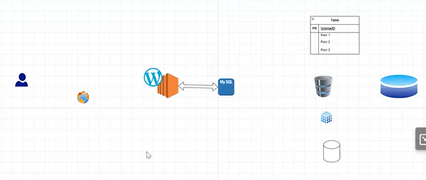

Create a SG with the Port Number >>> SSH, HTTP, ALL TCP, Custom TCP 3306 ( Port Number for MySQL)

Go to AWS Console and Select the Frankfurt Region .( for free tier MySQL database )

Then Go to the Security Group

Click on Create SG

Then add all the inbound rules SSH, HTTP, ALL TCP, Custom TCP 3306

SG-RDS created

Check the inbound rules again

Launch a RDS instance (Standard create)

Select creation Method as Standard create

Select engine as MySQL

Templates >>> Free Tier ( Select MySQL database )

DB Identifier - mahesh

Give username - mahesh

Credentials management >>> Self Managed

Master pwd - mahesh123

Select the db.t3.micro Instance

Storage >>> 20 GB

Storage autoscaling >> extract

Autoscaling - uncheck

Connectivity >>> Don’t connect to an EC2 compute resource

Select VPC

DB Subnet group default

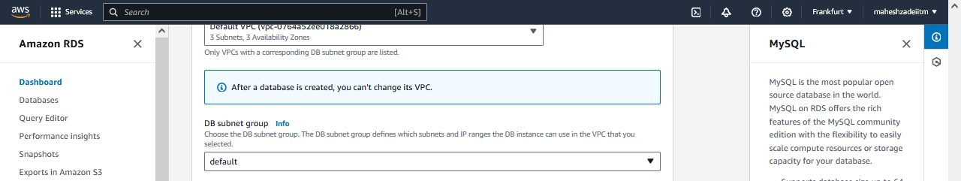

Public Access - NO

SG - Select dedicated SG which created above

Availability Zone - Public Subnet Zone from your VPC ( No preference)

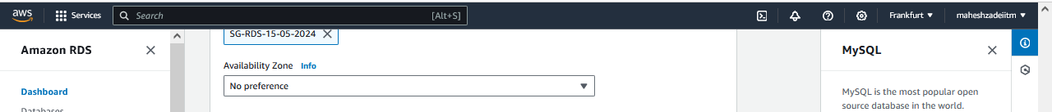

RDS Proxy >>> Leave it



Extract - Additional configuration

Database authentication >>> Password authentication

Monitoring >>> Leave it

Additional configuration >>>> Extract -

Initial DB name - mahesh

Disable - Automatic Backup ( uncheck )

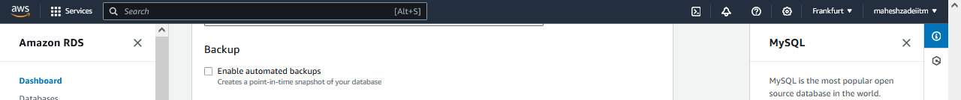

No Maintenance - Disable

Create a DB

Click on close

Database Started creating wait till created .

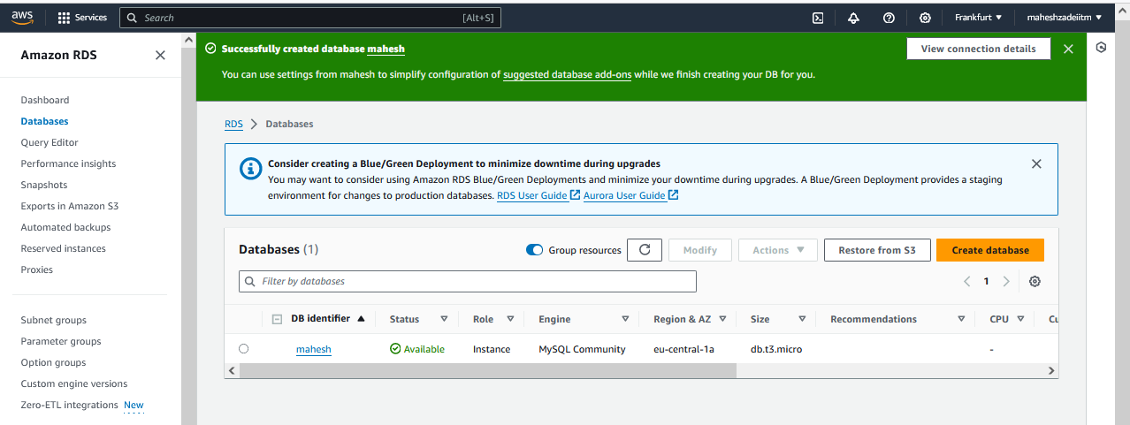

Pls make a note of endpoints

Below endpoint

mahesh.c9u2w60m8w4q.eu-central-1.rds.amazonaws.com

*****************************************************************

*****************************************************************

Launch a EC2 >>>>

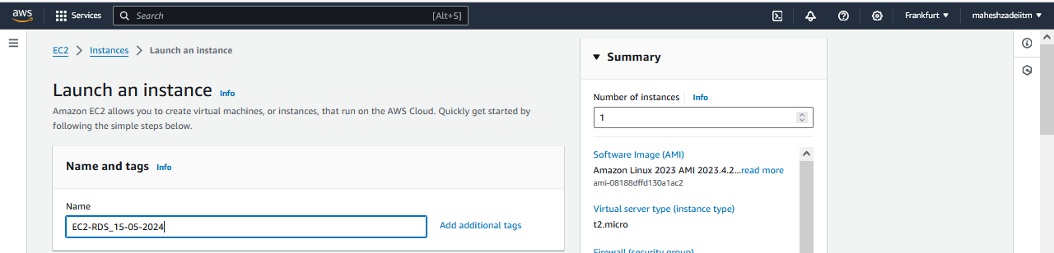

Amazon Linux 2

Choose VPC ( Here I select default and Public IP enabled )

Enable Public IP

SG - Use the same SG that you have created above

Extract Advanced >>> Update user data as below

Go to user data below and paste the below user data for word-press application

#!/bin/bash

yum update -y

amazon-linux-extras install -y php7.2

yum install -y httpd

systemctl start httpd

systemctl enable httpd

cd /var/www/html

wget https://wordpress.org/latest.tar.gz

tar -xzf latest.tar.gz

cp -r wordpress/* ./

chmod -R 755 wp-content

chown -R apache:apache wp-content

Launch EC2

Copy public IP of the EC2 instance and paste I browser.

Test Wordpress is launched or not >>> copy your Public IP and check in explorer

Now do the Integration steps below

DB Name - mahesh

username - mahesh

password - mahesh123

databasehost - DB endpoint

Remain default

Submit >>>> Integration test

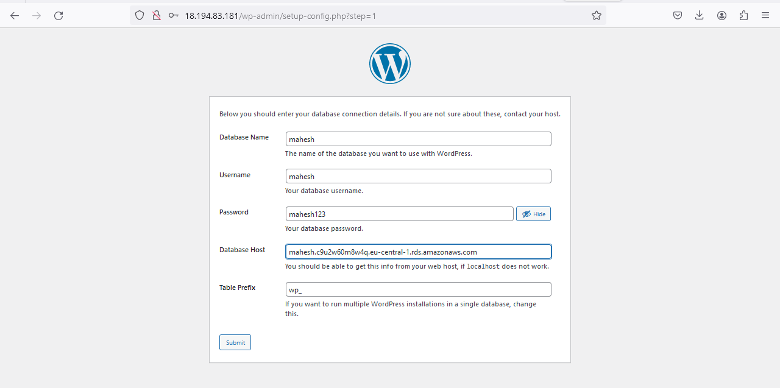

Click on Submit

login to the EC2

cd /var/www/html

ls

### NO config file,( wp-config.php) lets create it

sudo nano wp-config.php

Copy from wordpress app

update the one which you can see in wordpress page

Ctrl + X

Y

enter

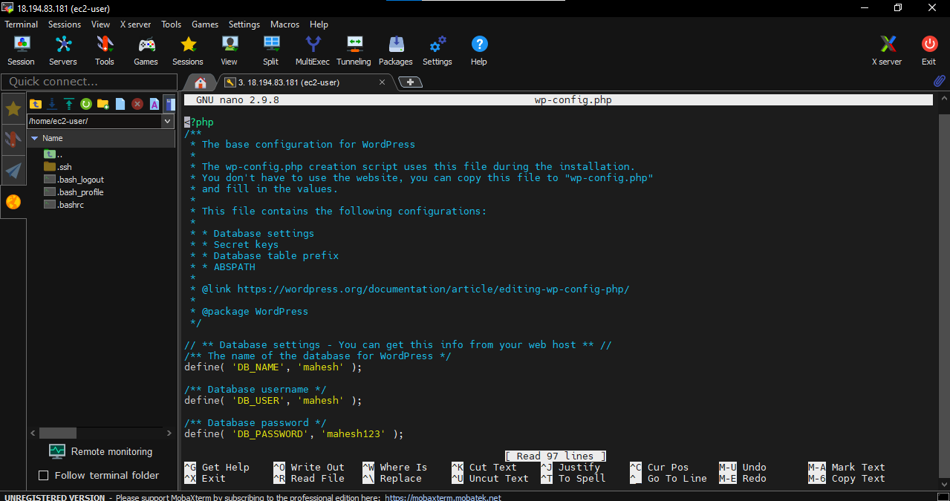

Test the connectivity from wordpress

Run the installation

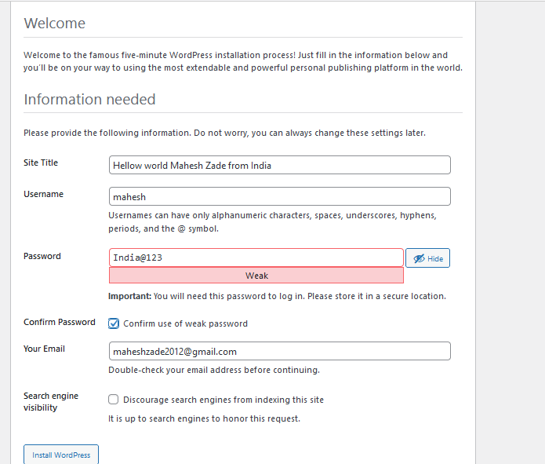

Click on login

Type user name and password you have given abaove

Go to post >>> add new post

Close welcome block editor

Add a tiltle

Now Click on publish

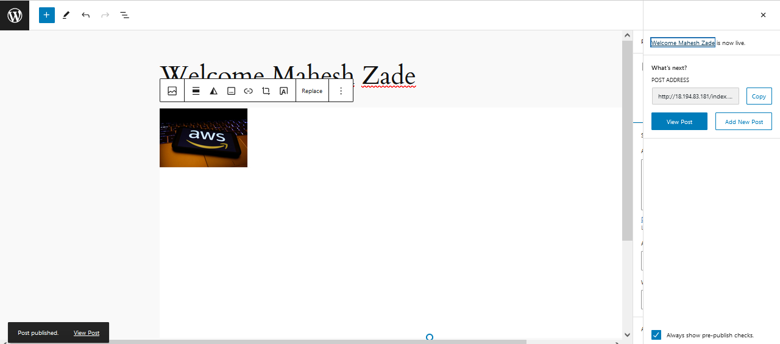

Copy URL from right side of the dashboard

<http://18.194.83.181/index.php/2024/05/15/welcome-mahesh-zade/>

Now my WordPress application is launch on RDS ( MySQL) successfully

Pls check and confirm

Thanks

